#### Block 2 Challenge Proposal details

Wire Frame example

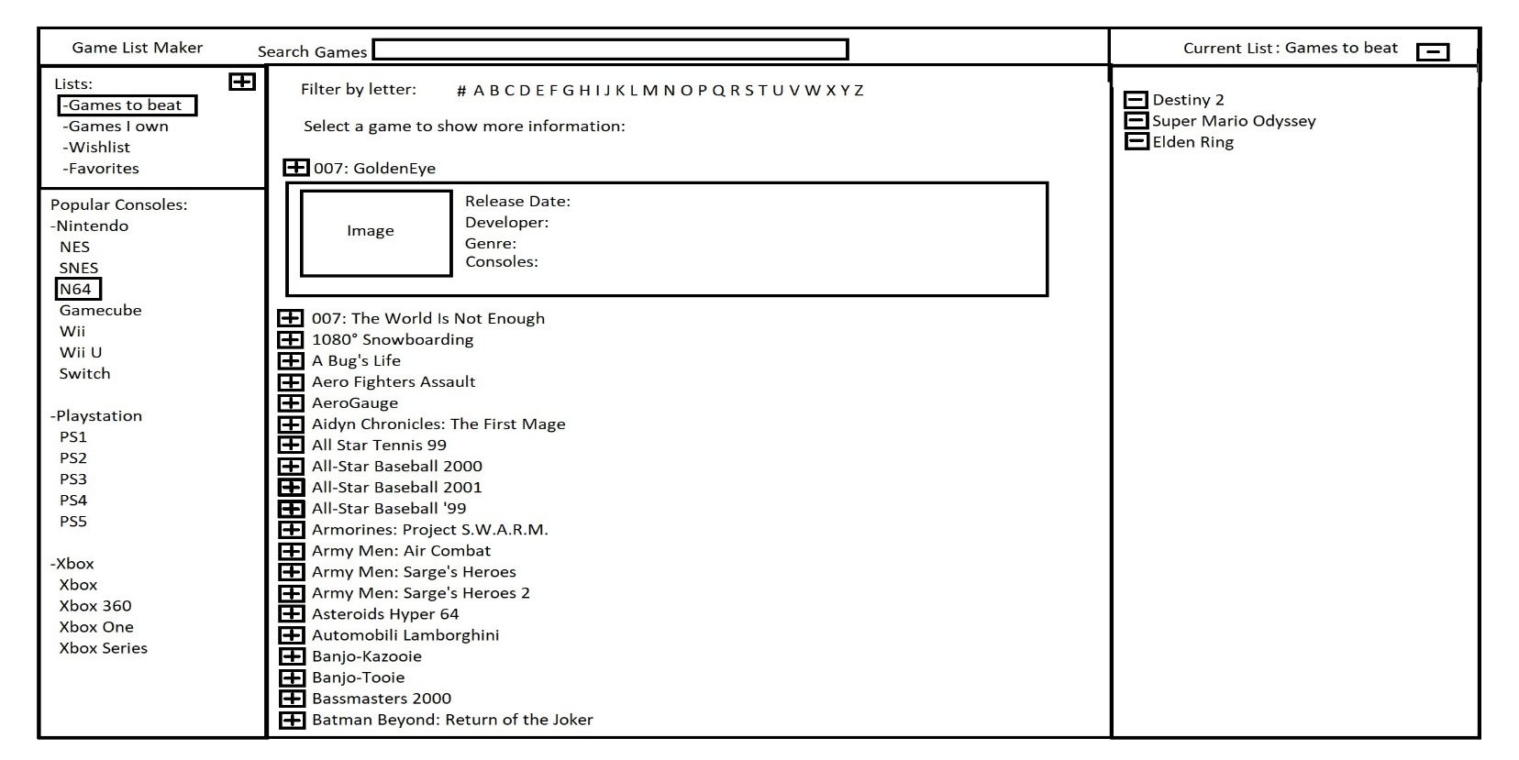

* **Purpose:**I think id like to build a basic app that lets you keep track of video games in a list (possibly a list of games to play and games beaten). It will pull info on the games from a API called RAWG which has 500,000+ games with their details.
* **Audience:**this would be for anyone who has interest in videogames and wants to browse them and make lists. I.E. list of games beat this year, list of games i want, list of games i still need to play.
* **Data Sources:**I found a public API called [RAWG games database](https://rawg.io/apidocs#why-rawg-api) . I think i will also use local storage to save the lists between sessions.
* **Initial Module List:**
  + setup - pulls data from the API and gets info from local storage to display
  + display - this function will display the results to the page
  + createList - this function will serve to create a new list
  + addToList - funciton to add a game to the current list
  + removeFromList - function to remove a game from the current list
  + deleteList - function to delete an entire list
  + refreshDisplay - function to refresh displayed information after selections have been made
  + search - gather results of a search and send to display or provide an error
* **Functionality:**
  + Search box at top of screen for easy searching
  + Navigate, create new list, or select an existing list
  + List navigation and console navigation are shown in the left bar
  + The highlighted list will be the one that changes are made to
  + if console is selected the list of games shows in the middle panel with alphabetical navigation
  + games can be selected for more details
  + using the addition button will add a game to the list displayed in the right panel
  + games can be removed from the list by using the remove button at the top of the right panel
* **Schedule:**
  + Week 1: Get connected to the API and get it to list data (details and images)
  + Week 2: get the search feature working (this will also allow for preset searches ie side bar)
  + Week 3: Build a list feature which can save to local storage
  + Week 4: build out addition features like add and remove and delete
  + Week 5: style the site to display correctly with smooth UI and looks appealing to use